Template Class List functions

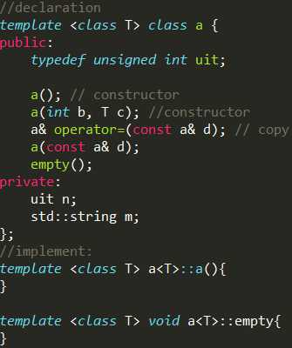List.erase(iterator) iterator points to next position

Return positon of erased iterator

List.insert(iter, n) insert n before iter, iter x change

List.push_back(n)

List.push_front(b)

List.begin() return first iter; List.end() return last iter

Order Notation

O (log n) dictionary lookup, binary search

O(n log n) sort

Merge sort: space O(n log n) Memory O(n)

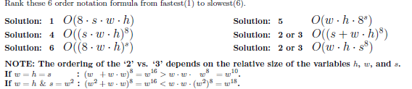

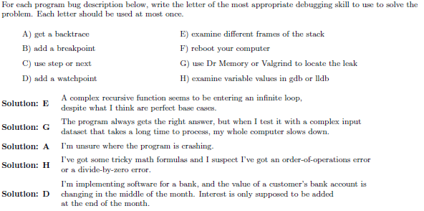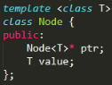

iclicker

1.what is the order notation of these 3 code fragments in term of n?

